**8-BIT MULTIPLICATION:**

**EXP NO:3**

**AIM:**To write an assembly language program to implement 8-bit addition using 8085  
processor.

**APPARATUS:** GNUSim8085

**ALGORITHM:**

1)Start the program by loading a register pair with the address of the memory location.  
2) Move the data to a register.  
3) Get the second data and load it into the accumulator.  
4) Add the two register contents.   
5) Increment the value of the carry.  
6) Check whether the repeated addition is over.  
7) Store the value of the product and the carry in the memory location.  
8) Halt.   
**PROGRAM:**

   LDA 8500  
   MOV B, A  
   LDA 8501  
   MOV C, A  
   CPI 00  
   JZ LOOP  
   XRA A  
   LOOP1: ADD B  
   DCR C  
  JZ LOOP  
  JMP LOOP1  
  LOOP: STA 8502  
  RST 1

**INPUT:**

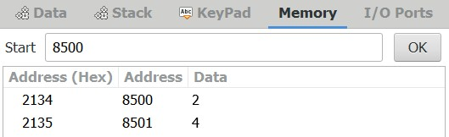

**OUTPUT:**

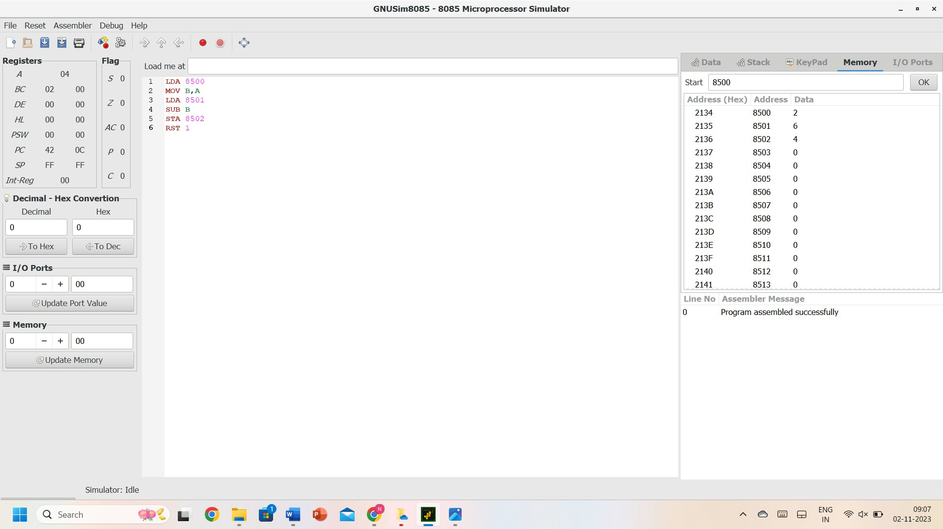

**RESULT:** Thus, the program was executed successfully using 8085 processor simulators.